OSSP Practical:
WEEK-5:
Section:09
M. Sreeya
Code:
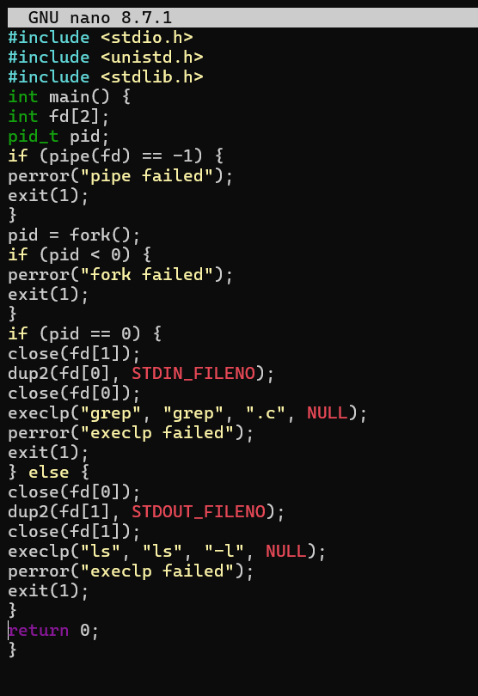

OUTPUT:
